2.6.1 Adding/Deleting a User - Bryan

When User selects the plus sign on the left side of the bottom row, the interface allows the user to submit an entry for a new student.

2.6.2 View a certain student’s previous tests -Bryan

When the User selects the view students button under the Teacher tab, a list of students shows up.

**2.6. Administrative Functions**

Scenarios in this section illustrate functions available to the system administrator. These functions allow an administrator to update the user, group, room, and global option databases.

**2.6.1. User Database**

When the user selects the `Users ...' item in the privileged `Admin' menu, the system responds with the dialog shown in Figure 22.

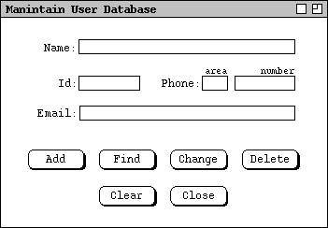

Figure 22: User database dialog.

*Need to explain all of the functionality.*

**2.6.1.1. Adding a User**

When the user selects the 'Users->Add' item from the 'Admin' menu, the system displays the dialog shown in Figure 23.

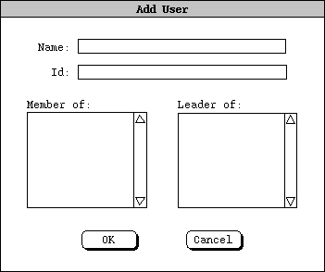

Figure 23: Add-user dialog.

**2.6.1.2. Deleting a User**

**2.6.1.3. Changing a User**

**2.6.1.4. Finding a User**

**2.6.2. Group Database**

*The group database dialog is similar to the user database dialog, as shown in Figure 24.*